Visit Report: Ramganj Upazila Health Complex, Lakshmipur
Date of Visit: 12/09/22; Time: 1:00 PM
Visitor: Dr. Md. Emdadul Haque, National Consultant (HEU) &
Dr. Nazmur Rahman Sajib, Junior National Consultant (HEU)

Objectives of the visit:
1. To perform the baseline health survey of the UHC
2. Discussion on the SSK program and importance of quality of health care.

Activities:
1. We arrived at 1:00 pm in the health complex. UH&FPO, RMO, medical officers and nurses were present in the health complex.
2. The Upazila Health Complex is 31 bedded. The infra-structure of the hospital building is 50 bedded since 2012. Till now, there is no administrative approval for functioning as 50 bedded hospital. But the condition is good. There are 10 unions under this UHC.
3. We met with the UH&FPO, RMO and other Medical Officers, discuss with them about the SSK and overall situation of the health complex. The post of Gynae and Anaesthesia consultant is filled up, so caesarean section is performed.
4. We visited outdoor of the Upazila Health Complex of Ramganj. The outdoor was crowded with patients. We observed OPD, Emergency, labour room, pathology and pharmacy department. There are one medical technologist (Lab). The information display system was better than any other UHC of Lakshmipur district, but the health education system is weak.
5. Cleanliness of the hospital premises and indoor was satisfactory. There is a separate operation theatre which is functioning.
6. There is no cycle stand close to the main gate. There are few motorcycles parked within corridor.
8. There are spaces in emergency, SSK Booth and Pharmacy can easily be established there.
10.The UHC was awarded by “Health Minister’s Award” in 2020.

Health Profile of Ramganj UHC, Lakshmipur
Total population: 3,13,500
Union: 10 Sub-centre: 8 FWC:2 Community Clinic: 27

Human Resources of Ramganj 31 Bedded Hospital:
Sl. | Designation | No. of Post | Present | Vacant
1. | UH&FPO | 01 | 01 | 0
2 | RMO | 01 | 0 | 01
3. | Junior Consultant | 04 | 03 (Medicine, Anesthesia, Gynae) | 1 (Medicine Deputation at DH)
4. | Medical Officer | 13 | 9 | 4
5. | MO(Dental) | 1 | 0 | 1
6. | Medical Officer (OSD) | 7 | 7 | -
7. | Nurses | 25 | 23 | 2
8. | Mid wives | 4 | 3 | 1
9. | Medical Technologist (Lab) | 2 | 1 | 1
10. | MT EPI | 01 | 1 | 0
11. | MT(Dental) | 01 | 0 | 01
12 | MT (Radiology) | 01 | 0 | 01
13. | SACMO (UHC+ Field) | 2 | 2+1 | 0
14. | Pharmacist | 02 | 01 | 01
15. | Health Inspector (HI) | 05 | 1 | 04
16. | Sanitary Inspector | 01 | 1 | 0
17. | Assist. Health Inspector | 14 | 6 | 08
18. | Health Assistant | 69 | 59 | 10
19. | CHCP | 27 | 27 | 0
20. | Head Assistant | 01 | 0 | 01
21. | Cashier | 01 | 0 | 01
22. | Accountant | 01 | 0 | 01
23. | Statistician | 01 | 01 | 0
24. | OA/Comp. Operator | 03 | 02 | 01
25. | Store Keeper | 01 | 0 | 01
26. | Cardiographer | 0 | 0 | 0
28. | MLSS+ Ward boy | 07 | 05 | 02
29. | Cleaner | 05 | 01 | 04
30. | Guard | 02 | 01 | 0
31. | Gardener | 01 | 0 | 01
32. | Cook | 02 | 02 | 0
33. | Attendant (Lab, emergency, OT) | 0 | 0 | 0
34. | Driver (Ambulance) | 01 | 1 | 0
35. | Outsourcing: Driver | 01 | 1 | 0
36 | FWV | 13 | 06 | 07
37. | FWA | 59 | 38 | 21
38. | FPI | 11 | 08 | 03

Status in HSS Score From Jan-July. (Total Dist. Hospital-64, Total UHC-423)
Name | Jan | Feb | Mar | April | May | June | July | Aug
Lakshmipur District Hospital | 2 | 1 | 2 | 2 | 3 | 3 | 55 | 55
Raipur UHC | 87 | 121 | 127 | 306 | 228 | 92 | 358 | 374
Ramganj UHC | 31 | 4 | 13 | 75 | 83 | 120 | 364 | 372
Kamalnagar UHC | 154 | 119 | 59 | 176 | 168 | 289 | 385 | 380
Ramgati UHC | 196 | 117 | 96 | 265 | 219 | 212 | 356 | 369

Status of Building Blocks of C-J Model in the Ramganj UHC:
Sl | Criteria of C-J Model | Satisfactory | Average | Weak
 | Cycle stand close to the main gate |  |  | √
 | Health Education |  | √
 | Cleanliness & beautification |  | √
 | Separation of patients in out door & indoor |  |  | √
 | Blood donor list with 24/7 B.T facility |  |  | √
 | Birth- death recording |  | √
 | Reception Desk |  | √
 | Developed Emergency Dept. | √
 | 5S –KAIZEN implementation. | √
 | Community Participation. |  | √
 | Hospital activities Display |  | √
 | Corner based service. |  | √
 | Cash counter for receiving Govt money. |  |  | √
 | Devolped maternal health/labour word. |  | √
 | Devolped paediatric health |  | √
 | Position in HSS score (Best= <100;  Good= 101-200; Weak= >200) |  |  | √
 | Power point Presentation &Video on UHC |  | √
 | Knowledge about 8th Five Year plan & SDG. |  |  | √
 | Zero-Tollarance on corruption |  | √

** Cell counter, 12 O₂ cylinder donated by MP, central O₂ system and 2 deep tube-well by Mayor. Waste management is done twice weekly by Mayor.

Recommendations:
1. The 50 bedded infra-structure of the health complex has been completed and hand overed and got administrative approval 10 years ago. But the posts of human resource yet not got approved. It is necessary for starting SSK program.
2. For better office management, the post of Head Assistant, Cashier and Accountant are very important. All the post are lying vacant. It should be filled up immediately.
3. The UHC is neat and clean.They follow the 5S KAIZEN-TQM policy to improve the quality of care. Role of pouroshova is satisfactory in cleaning the UHC. This centere can be a learning centre for the other health complexes of Lakhmipur.
4. There is a functioning OT room performing C-section 24/7, which is a good example for other UHC in Lakshmipur.
5. Radiological services are non-functioning due to vacant post of Medical Technologist (Radiology). It should be filled up immediately.
6. All the vacant posts of 4th class should be fulfilled immediataely.
7. OPD and IPD should be separated for male, female, Obstetrics & Gynae and children.
8. There should be a cycle stand close to the main gate.

Photos of Ramganj UHC taken from the visit are shown below:
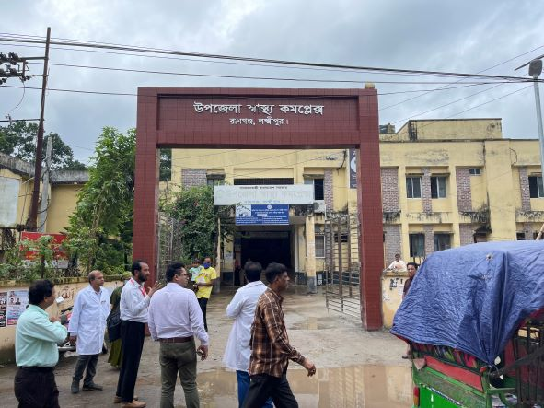
Fig-1: Front Gate of the Ramganj UHC

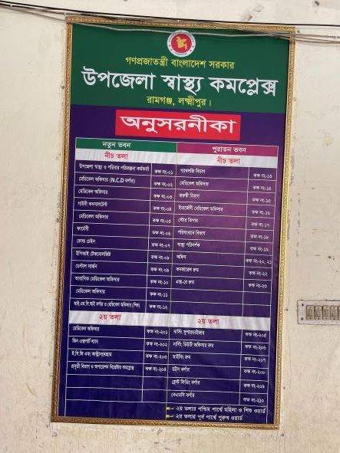

Fig-2: Guiding Board for location of the departments (Good Practice)

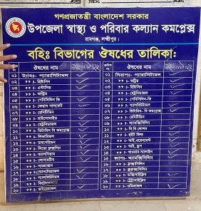

Fig-3: Supplying Drug List
(Good Practice)

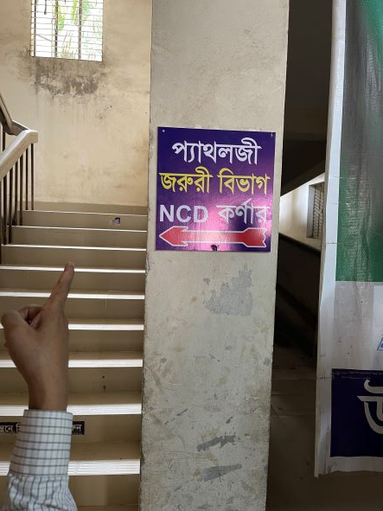
Fig-4: Guiding Sign for departments (Good Practice)

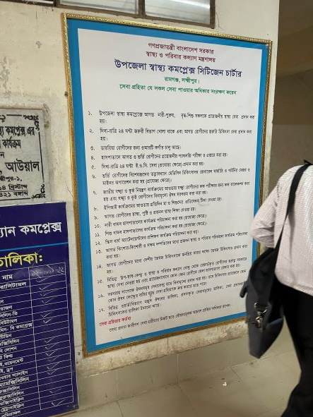

Fig-5: Citizen Charter (Good Practice)

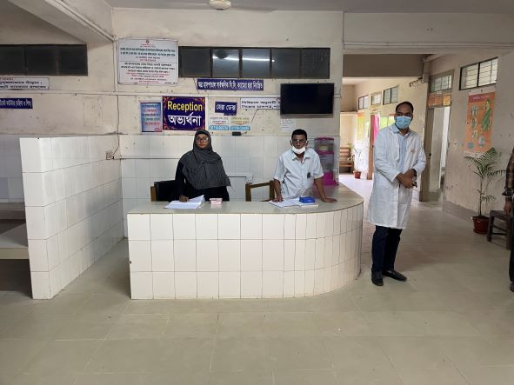

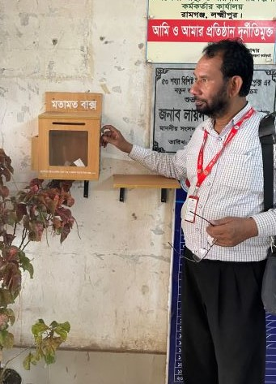
Fig-6: Reception Desk

Fig-7: Suggestion Box (Good Practice)

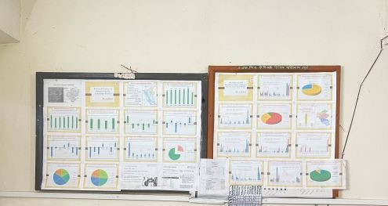
Fig-8: Updated Display Board of Office room (Good Practice)
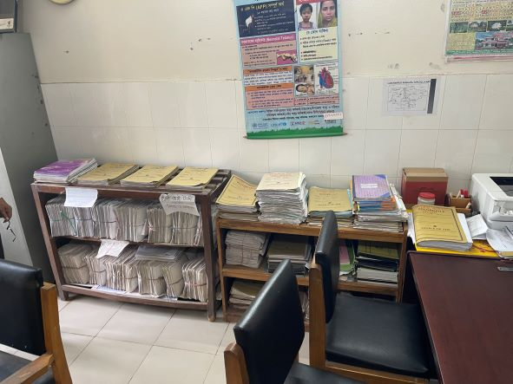

Fig-9: Organized Office filing system (Good Practice)

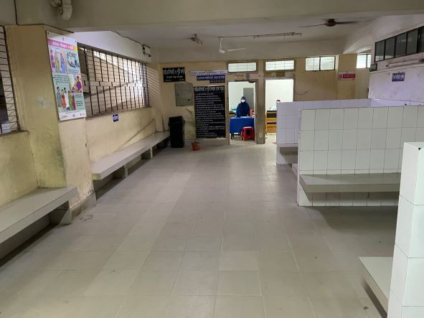
Fig-10: Proposed area for giving health education for patients and their attendants
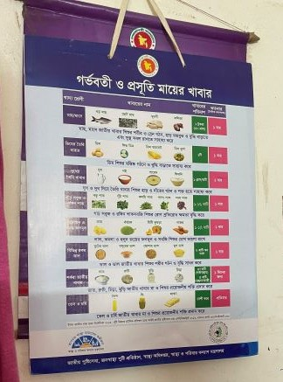

Fig-11: Nutritional chart for pregnant (Good Practice)

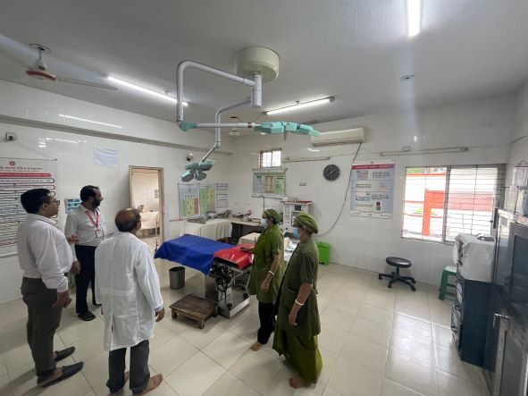

Fig-12: Functional OT room
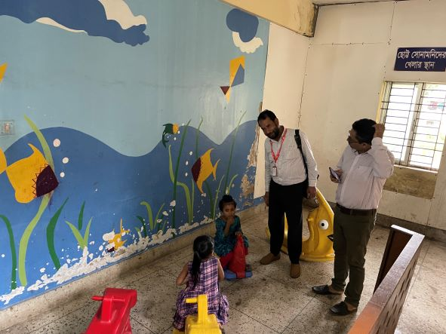

Fig-13: Kid’s Corner (Good Innovation)
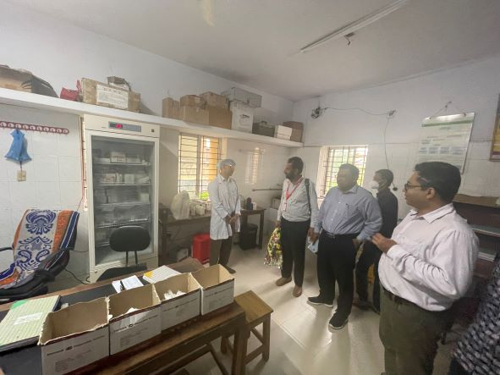

Fig-14: Organized Pathology room
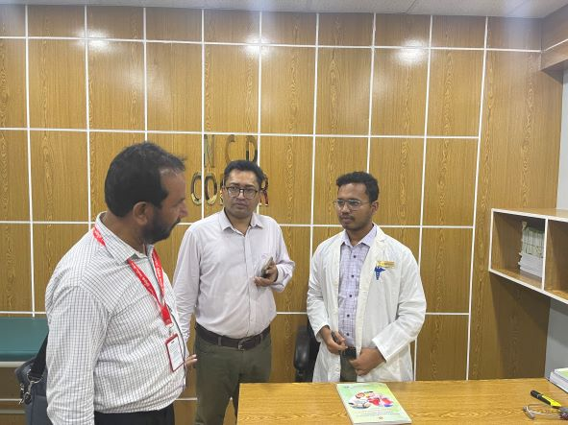

Fig-15: NCD Corner
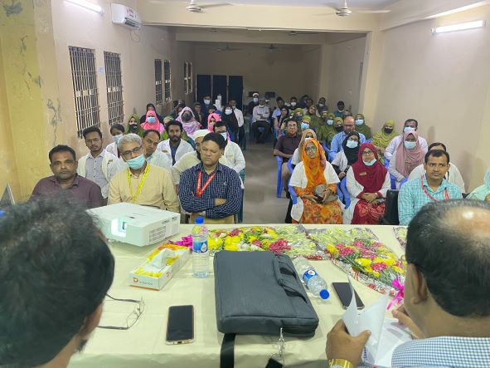

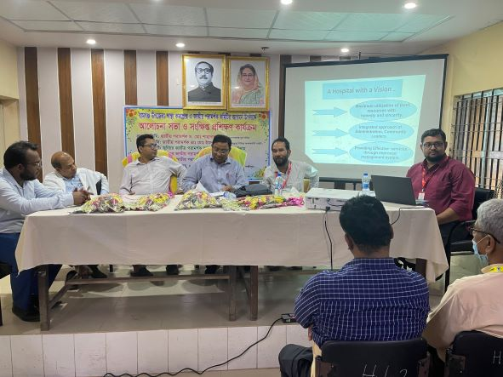

Fig-16: Discussion on SSK and Health Care Quality with Hospital Staffs

Fig-17: Participants of the Discussion session

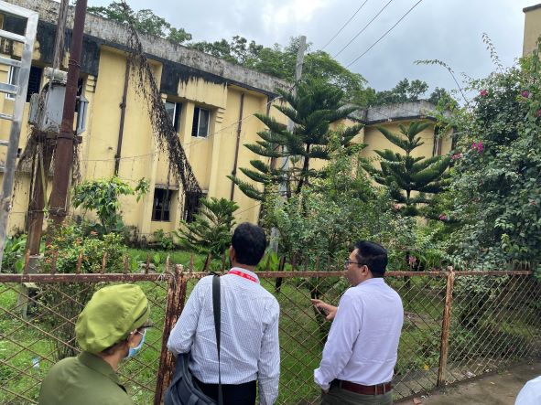

Fig-18: Unclean garden area in front of the health complex
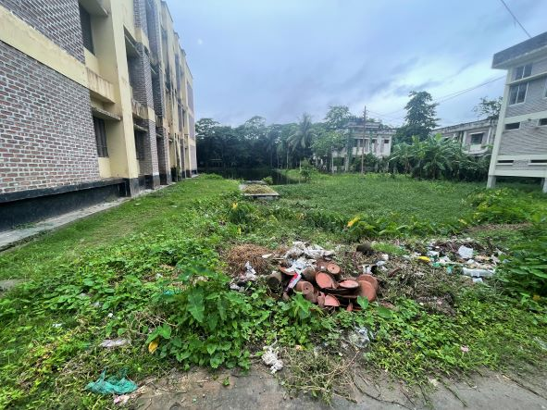
Fig-19: Unclean area behind the health complex

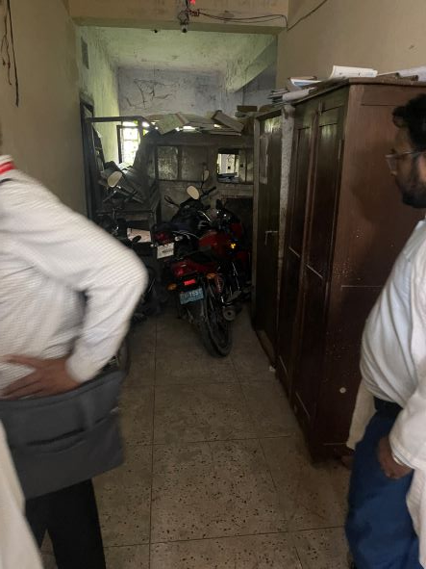
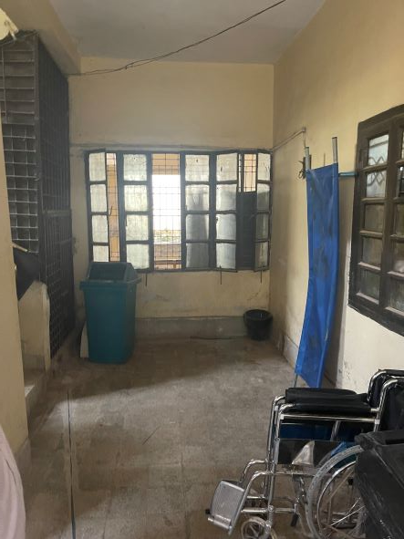

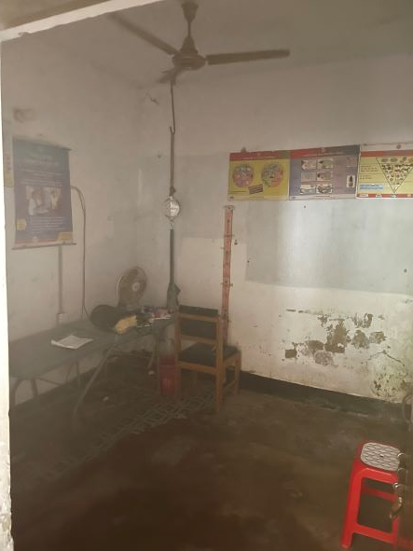
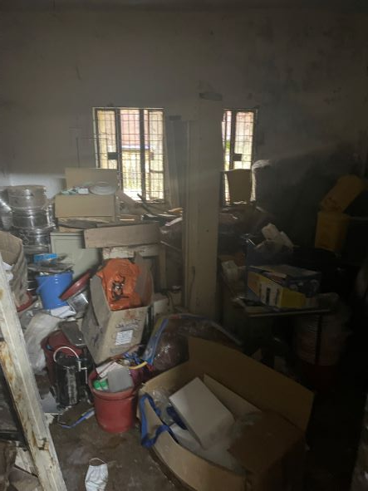

Fig-20-23: Proposed areas for SSK booth and SSK Pharmacy

